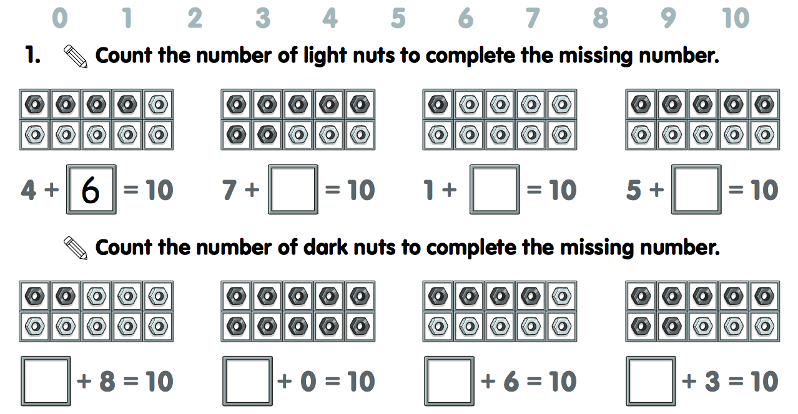

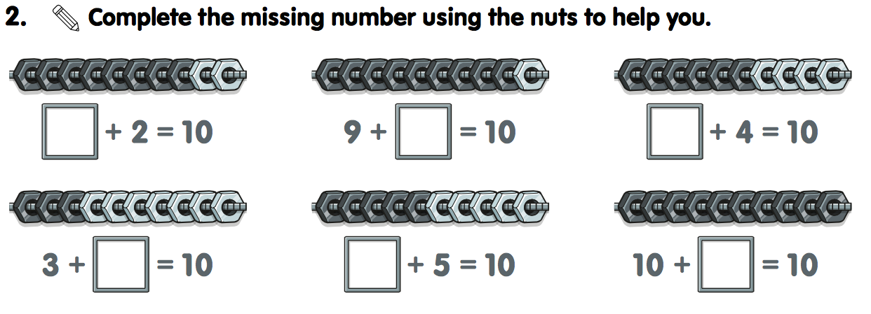

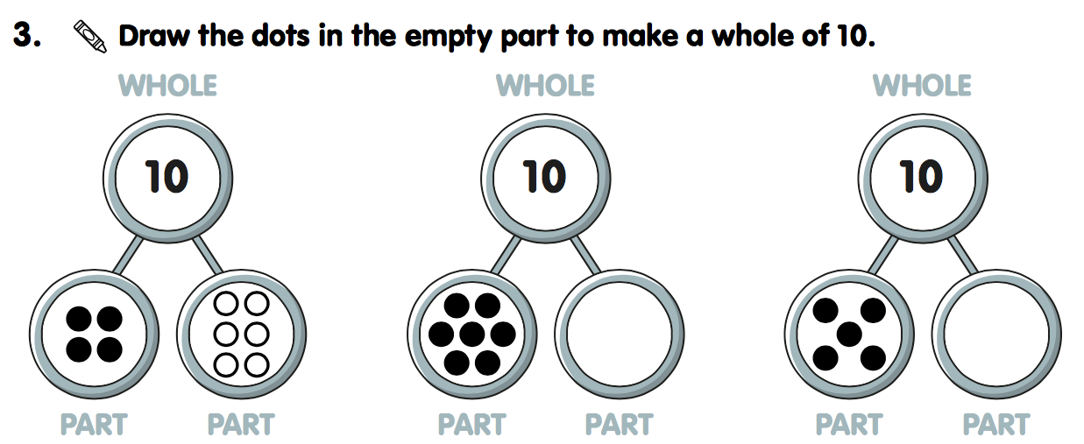

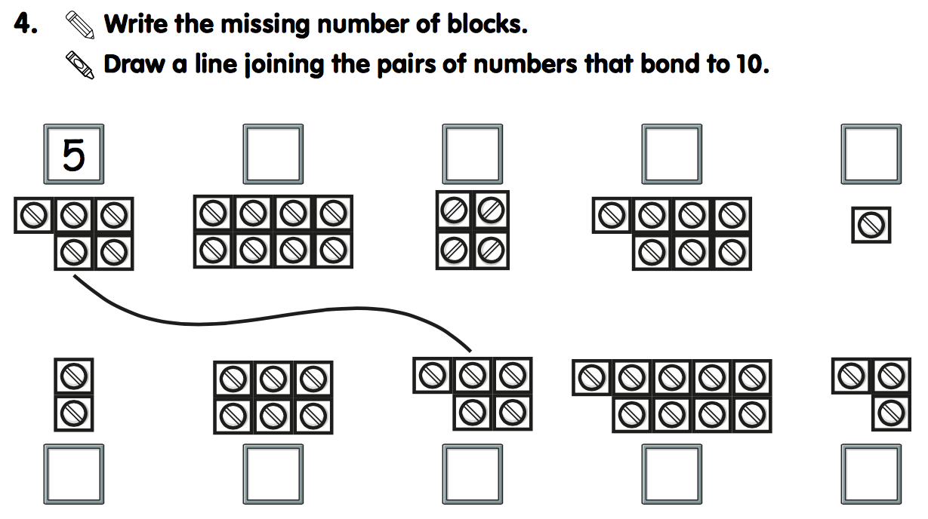

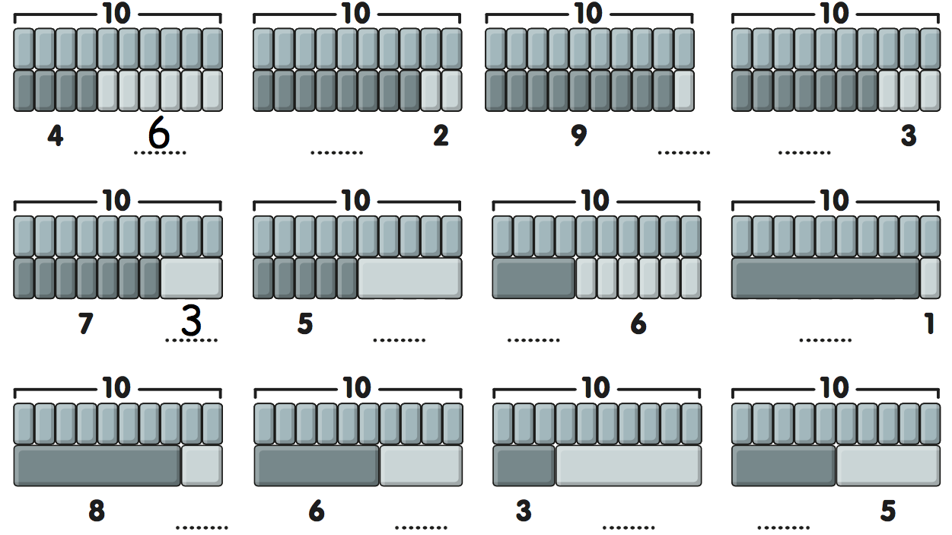

Year 2 Homework

Test Date: 18th September

We will be holding our first mental arithmetic test on Thursday 18th September, and it will focus on number bonds to 10.

By the end of this term, the children should be able to recall all number bonds to 10 quickly and confidently. To support this, I’ve provided some paper-based activities for your child to practise at home.

In addition, I highly recommend using the online game “Hit the Button” on the Topmarks website. It’s a fantastic and fun way to help children improve their speed and accuracy with number bonds.

This is also something we will be revisiting regularly during our Maths Meetings to help embed this important skill.

Thank you for your continued support in helping your child build strong foundations in maths.