Year 2 Maths Homework

Test Date – Thursday 19th June 2025

This week in our mental arithmetic homework, we will be focusing on counting in steps of 3s.

The children have been working hard and are now confident at verbally counting in 3s. They will be using this skill to help them solve a variety of questions, including identifying missing numbers, counting forwards and backwards, and simple multiplication.

To support them, we’ve included a number line that counts in 3s, which they can refer to if they need a little extra help. Encouraging your child to say the numbers out loud as they count can also be a great way to reinforce their learning.

1. What is 3 more than 9?
2. Count in 3s from 0. What is the 5th number?
3. What number comes after 15 when counting in 3s?
4. What is 3 less than 21?
5. Fill in the missing number: 3, 6, ___, 12
6. How many 3s are there in 18?
7. What is the 7th number when counting in 3s?
8. If you count in 3s from 0, what number will you say after 6 steps?
9. What number is missing? ___, 9, 12, 15
10. What is 3 more than 24?
11. What number comes before 27 when counting in 3s?
12. Fill in the blank: 3, ___, 9, 12
13. What is 3 × 4?
14. What is 3 × 6?
15. What is 3 less than 30?
16. What number comes after 6 when counting in 3s?
17. What is the 10th number in the 3 times table?
18. If you start at 3 and count in 3s, what number will you say after 8 steps?
19. What number is missing? 6, 9, ___, 15
20. What is 3 more than 0?

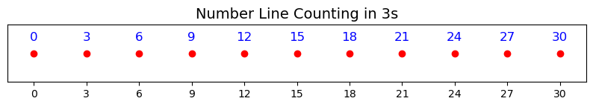

This is the song that we use to sing our three times table at school which can be found on YouTube:

