Welcome to your MHFA Wellbeing Bulletin - October 2022

Hi Everyone, we all hope you are all keeping well!

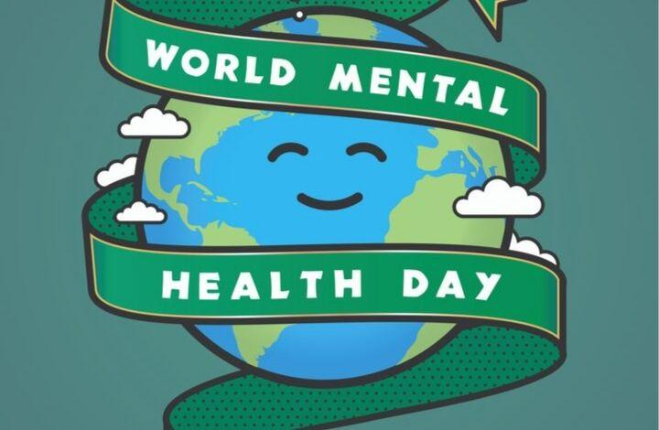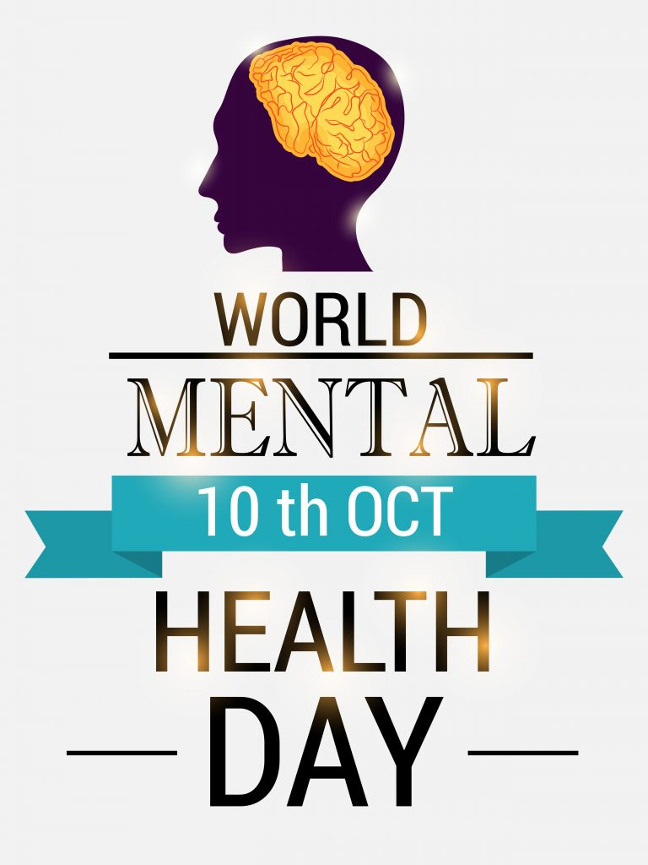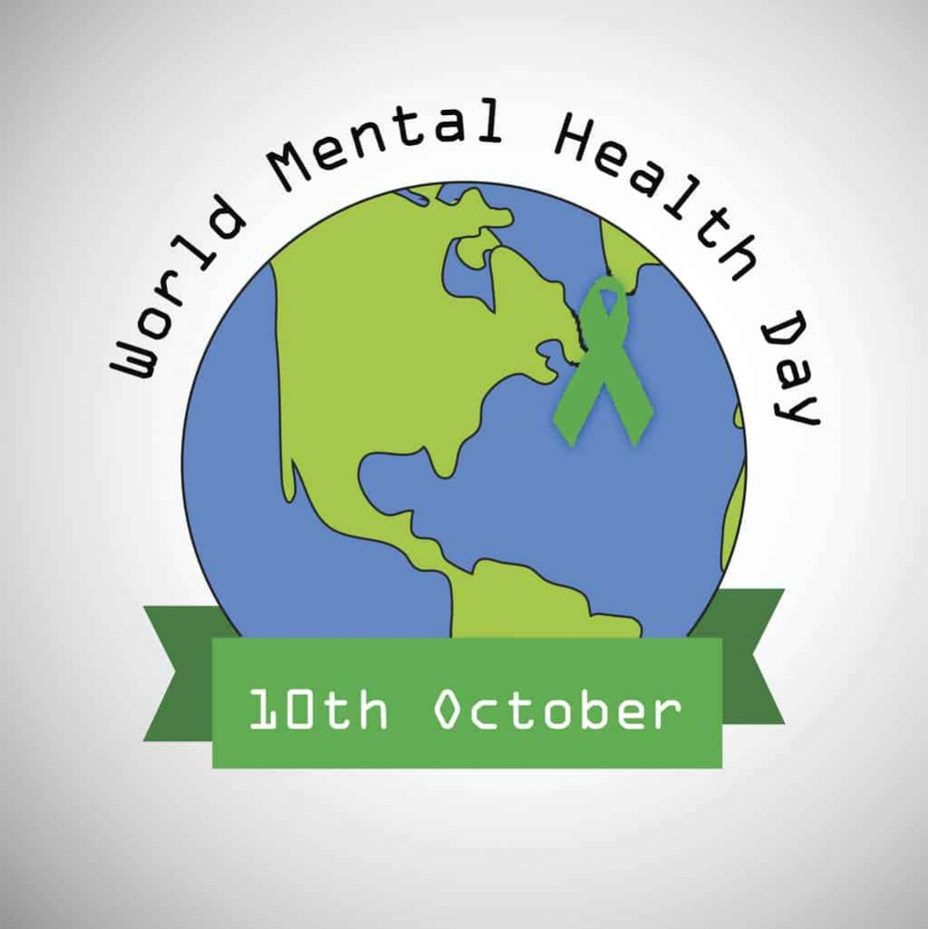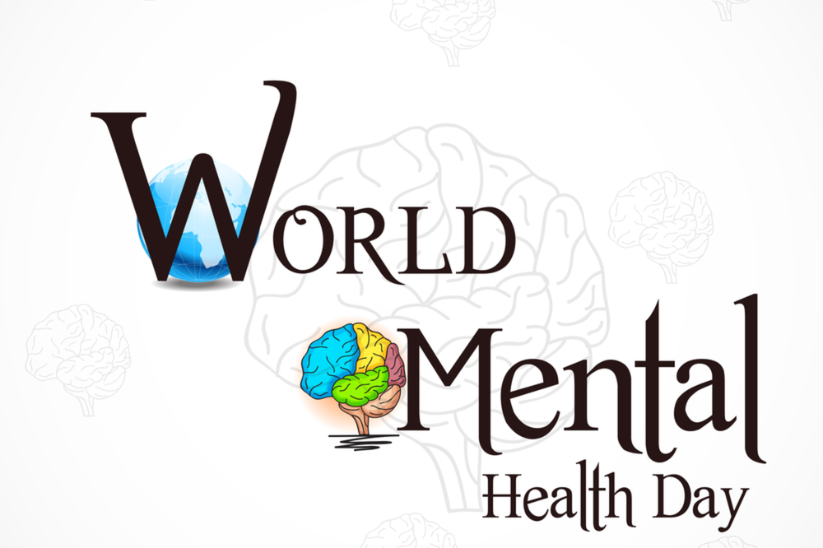

#WorldMentalHealthDay - 10th October 2022

World Mental Health Day will be celebrated on the 10th October 2022, with the theme 'Make Mental Health & Well-Being for All a Global Priority'. This theme was chosen by a global vote that was open to the public.
For those of us experiencing mental illness, we live in an unequal world. There’s no two ways about it. Stigma. Discrimination. Lack of support. Limited access to housing, employment and welfare. It doesn’t make good reading.
Things are slowly starting to change. Stigma around some mental health issues such as anxiety and depression have improved, the NHS Long Term Plan has committed to creating a community model of mental health care and the government is in the process of reforming the Mental Health Act.
People living with severe mental illness still have a shorter life expectancy than others. And the cost of living crisis is plunging thousands of people across the country into debt.
Good mental health is not simply the absence of diagnosable mental health problems, although good mental health is likely to help protect against development of many such problems.

Good mental health is characterised by a person’s ability to fulfil a number of key functions and activities, including:

- the ability to learn
- the ability to feel, express and manage a range of positive and negative emotions
- the ability to form and maintain good relationships with others
- the ability to cope with and manage change and uncertainty.

- Talk about your feelings
Talking about your feelings can help you stay in good mental health and deal with times when you feel troubled.

Talking about your feelings isn’t a sign of weakness. It’s part of taking charge of your wellbeing and doing what you can to stay healthy.

Talking can be a way to cope with a problem you’ve been carrying around in your head for a while. Just being listened to can help you feel supported and less alone. And it works both ways. If you open up, it might encourage others to do the same.

It’s not always easy to describe how you’re feeling. If you can’t think of one word, use lots. What does it feel like inside your head? What does it make you feel like doing?

You don't need to sit your loved ones down for a big conversation about your wellbeing. Many people feel more comfortable when these conversations develop naturally - maybe when you're doing something together.

If it feels awkward at first, give it time. Make talking about your feelings something that you do.

- Keep active
Experts believe exercise releases chemicals in your brain that make you feel good. Regular exercise can boost your self-esteem and help you concentrate, sleep, and feel better.

Exercise also keeps the brain and your other vital organs healthy.

Exercising doesn’t just mean doing sport or going to the gym. Walks in the park, gardening or housework can also keep you active.

Experts say most people should do about 30 minutes’ exercise at least five days a week.

Try to make physical activity that you enjoy a part of your day.

- Eat Well
Your brain needs a mix of nutrients in order to stay healthy and function well, just like the other organs in your body. A diet that’s good for your physical health is also good for your mental health.

Drink sensibly

We often drink alcohol to change our mood. Some people drink to deal with fear or loneliness, but the effect is only temporary.

When the drink wears off, you feel worse because of the way the alcohol has affected your brain and the rest of your body. Drinking is not a good way to manage difficult feelings.

Keep in touch

There’s nothing better than catching up with someone face to face, but that’s not always possible. You can also give them a call, drop them a note, or chat to them online instead. Keep the lines of communication open: it’s good for you!

- Ask for help

None of us are superhuman. We all sometimes get tired or overwhelmed by how we feel or when things don’t go to plan.

If things are getting too much for you and you feel you can’t cope, ask for help. Your family or friends may be able to offer practical help or a listening ear.
- Take a break
A change of scene or a change of pace is good for your mental health.
It could be a five-minute pause from cleaning your kitchen, a half-hour lunch break at work, or a weekend exploring somewhere new. A few minutes can be enough to de-stress you. Give yourself some ‘me time’.

Do something you’re good at

What do you love doing? What activities can you lose yourself in? What did you love doing in the past?

Enjoying yourself can help beat stress. Doing an activity you enjoy probably means you’re good at it, and achieving something boosts your self-esteem.

Accept who you are

We’re all different. It’s much healthier to accept that you’re unique than to wish you were more like someone else. Feeling good about yourself boosts your confidence to learn new skills, visit new places and make new friends. Good self-esteem helps you cope when life takes a difficult turn.

- Care for others
Caring for others is often an important part of keeping up relationships with people close to you. It can even bring you closer together.
‘Friends are really important… We help each other whenever we can, so it’s a two-way street, and supporting them uplifts me.’
Why not share your skills more widely by volunteering for a local charity? Helping out can make us feel needed and valued and that boosts our self-esteem.
It also helps us see the world from another angle. That can help to put our own problems in perspective.
Find out more about volunteering at www.do-it.org.uk.
Caring for a pet can improve your wellbeing too. The bond between you and your pet can be as strong as between people. Looking after a pet can bring structure to your day and act as a link to other people. Lots of people make friends by chatting to fellow dog walkers.
Best wishes from the NENCICB – South Tyneside MHFA team: Anna Davidson, Jane Leighton and Paula Talbot.

