Nursery Curriculum Overview Autumn Term 1 – Ourselves
What will your child be engaging in?
Personal, Social and Emotional Development  - Making new friends  - Playing alongside other children  - Sharing with others  - Using the toilet independently  - Using activities and resources independently  - Showing an awareness of themselves | Communication and Language  - Speaking in sentences  - Talking in a small group  - Communicating with friends  - Listening to others | Physical Development  - Moving freely with pleasure and confidence in a range of ways  - Discovering the outdoor area  - Using a range of large vehicles  - Holding pens, pencils and crayons  - Cutting out using scissors
Literacy  - Listening to and joining in with stories  - Taking part in rhyming and rhythmic activities  - Tuning into sounds including alphabet sounds  - Mark making | Mathematics  - Counting  - Using shapes  - Singing number rhymes and songs | Understanding the World  - Becoming familiar with the nursery environment  - Sharing personal news  - Knowing about themselves, their body, family, friends, where they live etc.
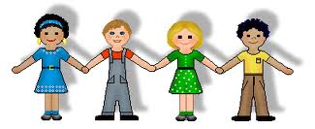 | Expressive Arts and Design  - Singing and dancing – beat and tempo  - Playing with musical instruments – beat and tempo  - Cutting and sticking  - Using sand/water/ play dough/paint  - Role play

